THE NEOTIA UNIVERSITY
Department of Computer Science & Engineering — AI & ML
PROJECT DEVELOPMENT DOCUMENT
AI Financial Analyzer
Automated Payslip-Based Loan Eligibility & AI-Driven Bank Statement Categorization
✦
NAME  Ritam Halder | UNIVERSITY  The Neotia University
UID / ROLL  TNUR20241053013 | INTERNSHIP COMPANY  Kognitive
DEPARTMENT  CSE (AI & ML) | INTERNSHIP DURATION  15 Jun – 15 Jul 2026
SEMESTER  5th | SUBMITTED TO  Bikash Bej

KOGNITIVE INTERNSHIP PROGRAM · 2026

CONTENTS
Table of Contents
Abstract 3
1. Introduction & Problem Statement 4
2. Objectives & Key Advantages 5
3. System Architecture 6
4. Technology Stack 7
5. Module 1 — Payslip Analysis & Loan Eligibility 8
5.1 Screenshots: Login & Dashboard 9
5.2 Screenshots: Upload & Analysis Result 10
6. Module 2 — Bank Statement Analysis with BERT 11
6.1 Screenshots: Upload & Bar Chart 12
6.2 Screenshot: Pie Chart & Key Insights 13
7. Results & Conclusion 14
8. Future Scope & References 15

PROJECT OVERVIEW
Abstract
AI Financial Analyzer is a secure, login-protected web application that unites two independent financial-intelligence tools inside a single dashboard. The first module reads an uploaded payslip, detects its salary components — Basic, HRA, Medical, Conveyance and Other — computes the Gross and Net income, and instantly determines whether the applicant is eligible for a loan against a defined income threshold. The second module reads an uploaded bank statement, extracts every individual transaction, and classifies each one into a spending category using a fine-tuned BERT language model.
Both modules convert raw financial data into clear, interactive visualizations — pie charts for distribution and a bar plot for ranked category totals — removing the need for manual review of documents that are traditionally read line by line. The result is a faster, more consistent, and significantly more accessible way to evaluate loan eligibility and understand personal spending behaviour.
The system is built entirely in Python, using Flask for the backend, OCR and regex-based parsing for payslip extraction, and a transformer-based BERT model for transaction classification, with Matplotlib powering all visual output.
By keeping both tools inside a single authenticated dashboard, AI Financial Analyzer is designed to serve a wide range of everyday use cases — from an individual checking loan eligibility ahead of a bank visit, to a user simply trying to understand where their monthly salary actually goes. The emphasis throughout the design has been on speed, clarity and trust: every result is explained visually rather than buried in numbers, so the output is useful even to someone with no financial background.

CHAPTER 1
Introduction & Problem Statement
Introduction
Every loan application and every monthly budget begins with the same tedious task: reading a document and making sense of the numbers inside it. Payslips list salary components in inconsistent formats across companies, and bank statements list dozens of transactions with cryptic merchant codes instead of readable categories. Doing this by hand does not scale, and doing it inconsistently leads to poor financial decisions.
AI Financial Analyzer was built to remove that manual burden entirely — combining document parsing, rule-based decision logic, and a machine learning classifier behind one secure login, so that a payslip or a bank statement can be turned into a decision or an insight within seconds of being uploaded.
The Problem
Manually reading payslips and bank statements to judge loan eligibility or track expenses is slow, inconsistent, and requires a level of financial literacy that most individual users do not have. Loan applicants wait longer than necessary for an eligibility decision that is really just arithmetic, and everyday spending goes completely untracked simply because categorizing dozens of transactions by hand is tedious and error-prone.
Core Challenge
There is no single, secure, self-service tool that reads both a payslip and a bank statement, and turns each into an immediate, visual, actionable result — without manual data entry.
Scope of the Project
The scope of this project is intentionally focused on two high-value, self-contained problems rather than attempting to be a full personal-finance suite. Module 1 restricts itself to salary-slip parsing and a transparent, rule-based eligibility check, while Module 2 restricts itself to statement parsing and category-level classification. This narrower scope made it possible to reach a working, demonstrable system within the internship timeline, while leaving clear, well-defined extension points — outlined in the Future Scope chapter — for later development.

CHAPTER 2
Objectives & Key Advantages
Objectives
1. Extract salary components — (Basic, HRA, Medical, Conveyance) directly from an uploaded payslip
2. Compute income & eligibility — automatically calculate gross & net income and check loan eligibility against a defined threshold
3. Extract bank transactions — parse individual transactions from an uploaded bank statement
4. Classify with BERT — assign every transaction to a spending category using a BERT model
5. Visualize results — render salary structure and spending pattern as pie charts and bar plots
6. Secure access — provide a secure, login-protected dashboard for both tools
Key Advantages
Saves Time  Instant results instead of manual document review | Reduces Errors  Consistent, rule-based calculations every time
Secure Login  Dashboard access is protected behind authentication | Automatic Categorization  BERT classifies every transaction without manual tagging
Instant Eligibility  Immediate loan decision the moment a payslip is uploaded | Clear Visual Insights  Pie charts & bar plots make the data easy to read at a glance
Taken together, these objectives and advantages guided every design decision in the project — from choosing a rule-based eligibility check over a black-box model (for transparency), to choosing BERT for categorization (for accuracy on free-text, inconsistently formatted transaction descriptions).

CHAPTER 3
System Architecture
The application follows a straightforward, secure workflow: a user logs in, selects one of the two modules from the dashboard, and the corresponding pipeline takes over — from upload, through extraction and analysis, to a final visual result.
User Login → Dashboard (Select Module)
▼
MODULE 1 — PAYSLIP ANALYSIS | MODULE 2 — BANK STATEMENT ANALYSIS
Upload Payslip | Upload Bank Statement

OCR + Regex Extraction | Transaction Parsing

Eligibility Rule Engine | BERT Classification

Pie Chart + Verdict | Pie Chart + Bar Plot
Both pipelines share the same login and dashboard layer but run independently after that point — Module 1 relies on deterministic OCR and rule-based logic so its eligibility decision stays fully explainable, while Module 2 relies on a learned BERT classifier so it can generalize to transaction text it has never seen before. This separation keeps each module simple, testable, and easy to extend on its own.

CHAPTER 4
Technology Stack
The application is built entirely on a modern Python-based stack, chosen for strong ecosystem support in both natural language processing and data visualization.
Language  Python 3 | Backend Framework  Flask
Frontend  HTML5, CSS3, JavaScript | ML Model  BERT (Transformers, PyTorch)
OCR / Parsing  Tesseract OCR, pdfplumber, Regex | Data Processing  Pandas, NumPy
Visualization  Matplotlib | Auth & Storage  Session-based Login, SQLite
Flask was chosen over a heavier framework for its minimal footprint and quick routing between the login, dashboard and module pages, while Tesseract and pdfplumber together give reliable text extraction from both scanned images and native PDF payslips. Pandas and NumPy handle all tabular computation, and every chart in the application is rendered server-side with Matplotlib before being returned to the browser.

CHAPTER 5 · MODULE 01
Payslip Analysis & Loan Eligibility
This module allows a user to upload a payslip and receive an instant loan-eligibility decision, backed by a transparent view of every detected salary component.
1. Upload — User uploads a payslip in PDF, JPG or PNG format
2. Extract — OCR + regex parsing detects Basic, HRA, Medical, Conveyance & Other components
3. Compute — System calculates Gross and Net monthly income from the detected components
4. Decide — Net income is checked against the eligibility threshold to approve or reject the loan
5. Visualize — Salary structure is rendered as an interactive pie chart
Eligibility Rule
₹ 20,000 minimum net monthly income required for loan eligibility
Components detected: Basic • HRA • Medical • Conveyance • Other • Gross • Net
The ₹ 20,000 threshold was deliberately kept as a single, transparent, easily-adjustable rule rather than a trained model — which means every eligibility decision the system produces can be explained in one sentence, and the threshold itself can be tuned by a bank or lender without retraining anything.

CHAPTER 5.1
Screenshots: Login & Dashboard
Access to both tools is protected behind a secure login screen. Once authenticated, the user lands on a dashboard that lets them choose between the two available modules.
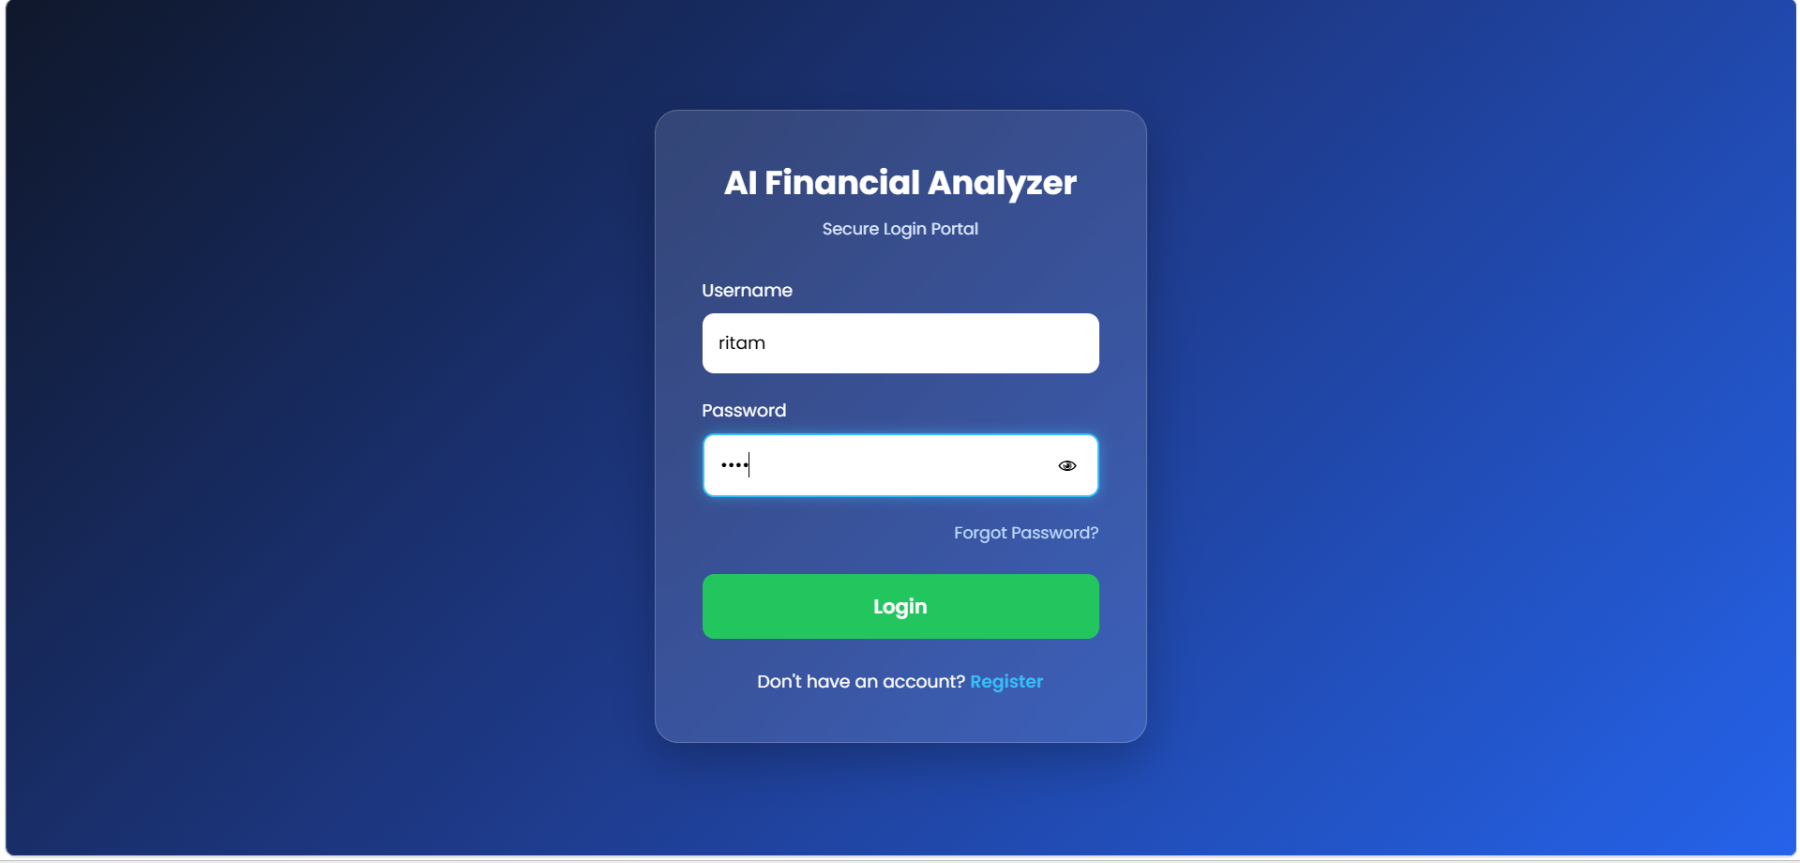
Figure 5.1(a) — Secure Login Portal
The login screen accepts a username and password and keeps the session authenticated for the duration of the visit, so that a user is never asked to re-enter their credentials while moving between modules.
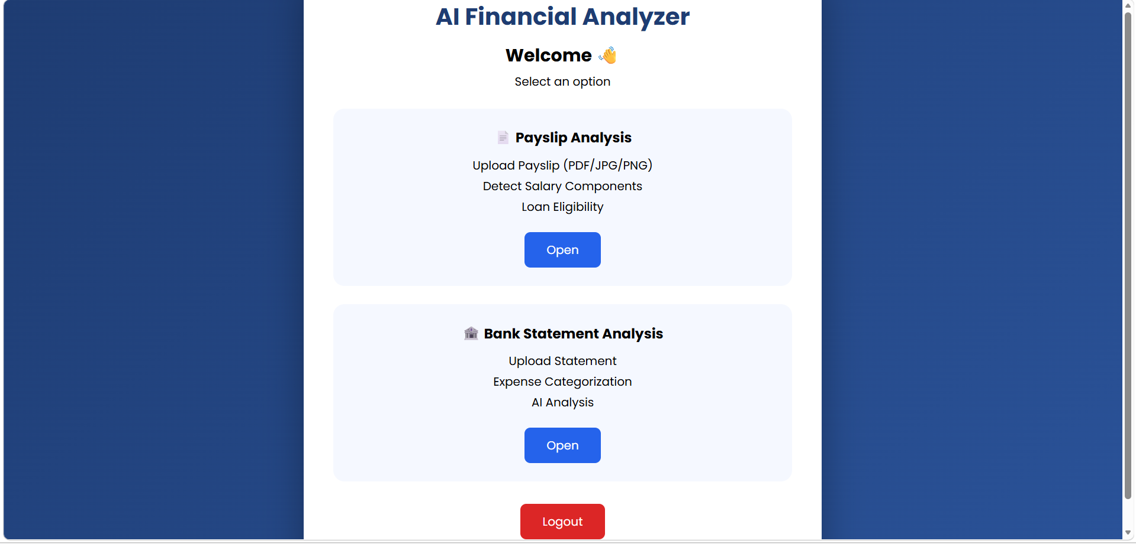
Figure 5.1(b) — Dashboard: Payslip Analysis & Bank Statement Analysis modules
The dashboard presents both modules as separate cards, each summarizing what it does before the user commits to uploading a document — keeping the interface predictable and easy to navigate even for a first-time user.

CHAPTER 5.2
Screenshots: Upload & Analysis Result
After uploading a payslip, the system displays the full component breakdown, the computed net income, the eligibility verdict, and a pie chart of the salary distribution.
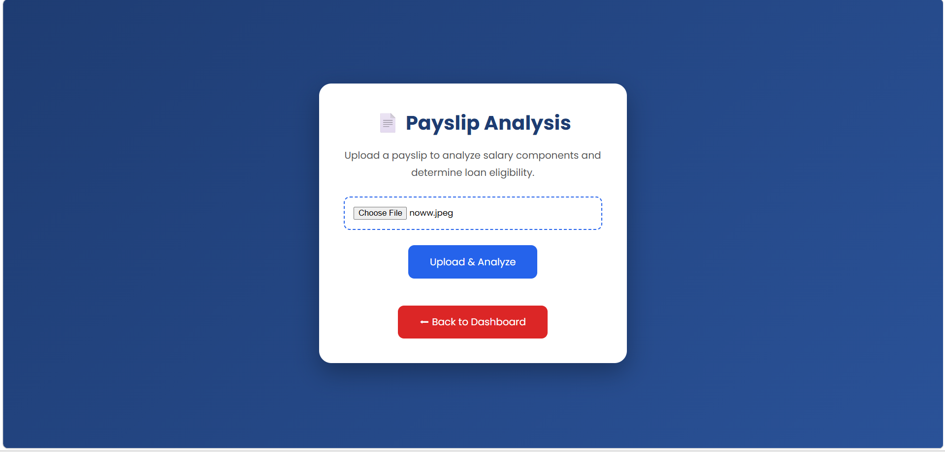
Figure 5.2(a) — Payslip Upload
The upload screen accepts PDF, JPG or PNG payslips and immediately hands the file to the OCR and extraction pipeline once “Upload & Analyze” is selected.
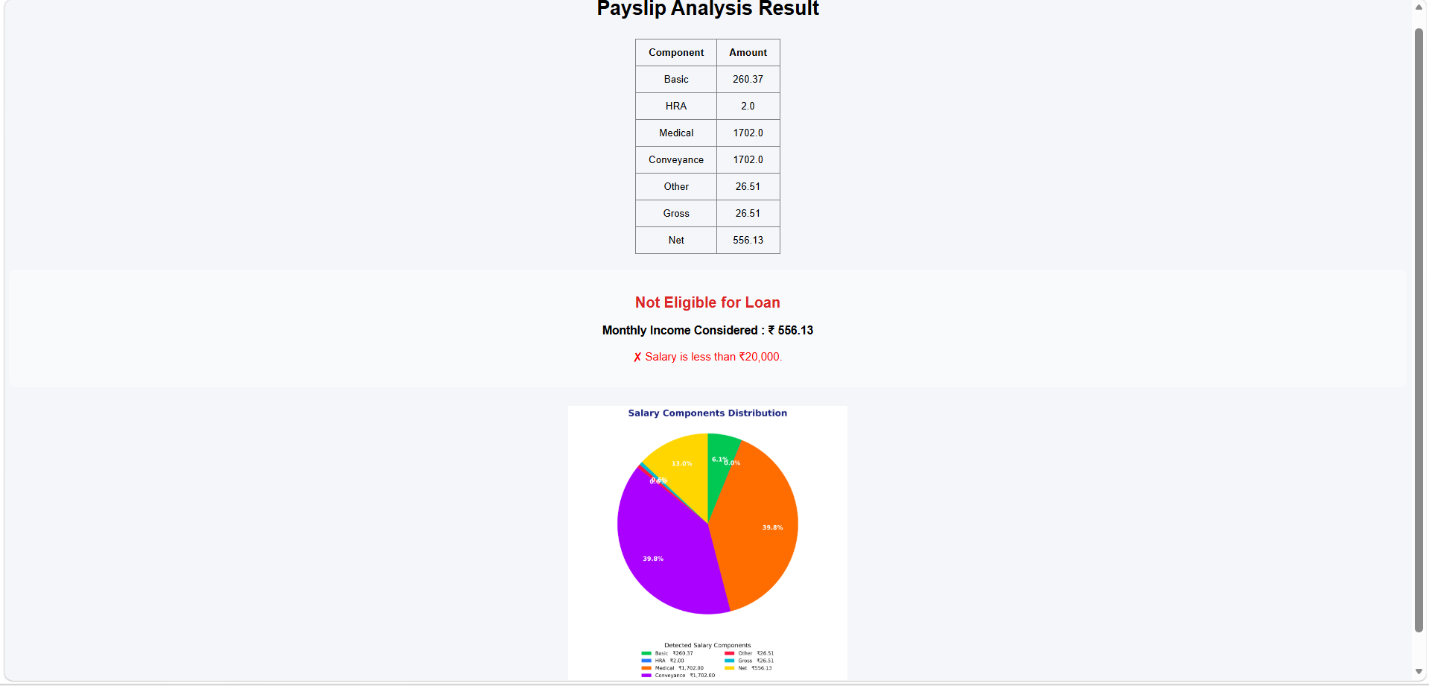
Figure 5.2(b) — Salary Breakdown, Verdict & Distribution Pie Chart
The result page lists every detected component in a plain table before rendering the pie chart, so the user can always trace the final verdict back to the exact numbers the system read from their document.
Sample Result: ✗ Not Eligible — Net income below ₹ 20,000 threshold

CHAPTER 6 · MODULE 02
Bank Statement Analysis with BERT
This module allows a user to upload a bank statement and receive an automatic, category-wise breakdown of their spending — powered by a BERT-based transaction classifier.
1. Upload — User uploads a bank statement PDF
2. Parse — Transactions (date, description, amount) are extracted from the statement
3. Classify — Each transaction description is passed through a fine-tuned BERT model to predict its category
4. Aggregate — Amounts are summed per category (Food, Transport, Medical, Shopping, etc.)
5. Visualize — Results are rendered as a category pie chart and a top-categories bar plot
BERT in Action
“SWIGGY *ORDER 500” → Category: Food – ₹500
BERT reads plain transaction text and maps it directly to a spending category — no manual tagging required.
Because BERT works directly on free text, it copes well with the inconsistent, abbreviated merchant strings that appear on real bank statements — without needing a hand-maintained list of keywords or merchant names to match against.

CHAPTER 6.1
Screenshots: Upload & Bar Chart
The bank statement upload screen highlights the module's core features before the user uploads a PDF for analysis. The resulting bar plot ranks categories by total amount spent.
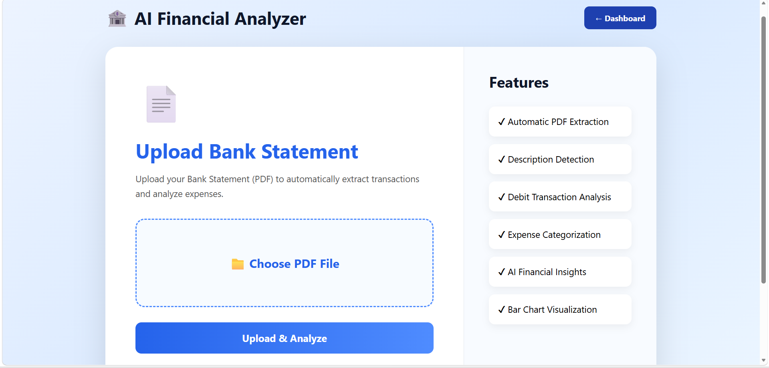
Figure 6.1(a) — Upload Bank Statement
The upload page lists the module's feature set alongside the upload control, so the user knows exactly what to expect — automatic PDF extraction, description detection, debit transaction analysis, category classification and both chart types — before they commit to uploading a statement.
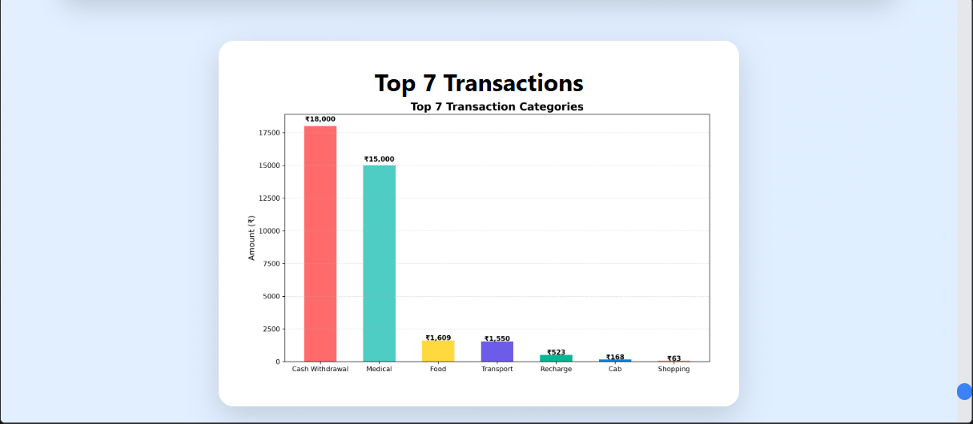
Figure 6.1(b) — Top 7 Transaction Categories (Bar Plot)
Ranking categories by absolute amount, rather than by transaction count, immediately surfaces where the largest sums of money actually went — which is usually more useful to a user than knowing which category had the most individual transactions.

CHAPTER 6.2
Screenshot: Pie Chart & Key Insights
The same categorized data is also rendered as a pie chart, giving a proportional view of spending that complements the ranked bar plot on the previous page.
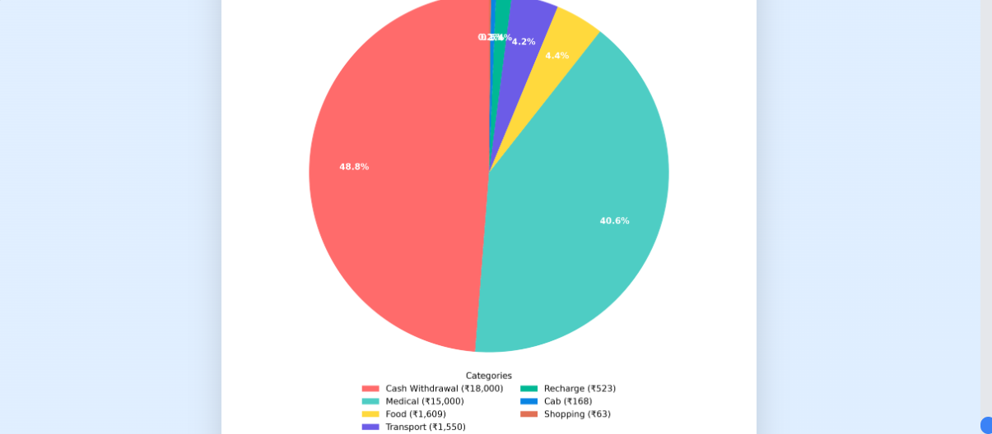
Figure 6.2 — Category-wise Expense Pie Chart
Category | % Share | Amount
Cash Withdrawal | 48.8% | ₹18,000
Medical | 40.6% | ₹15,000
Food | 4.4% | ₹1,609
Transport | 4.2% | ₹1,550
Recharge / Cab / Shopping | 2.0% | ₹754 combined
In this sample statement, cash withdrawals and medical expenses together account for close to 90% of total spending, while everyday categories such as food, transport and recharges make up a much smaller share — the kind of pattern that is easy to state in one sentence once the data is categorized, but would take considerable manual effort to work out from a raw statement.

CHAPTER 7
Results & Conclusion
Across both modules, the completed system meets the objectives set out at the start of this document: it reads real payslips and bank statements, turns them into structured data, and presents a decision or a breakdown that a user can act on immediately.
Key Results
- Automated salary component extraction from payslips
- Rule-based, instant loan eligibility decisions
- BERT-based classification of bank transactions
- Clear pie chart & bar plot visual reporting
- Secure, login-protected multi-module dashboard
Conclusion
AI Financial Analyzer successfully brings payslip-based loan eligibility assessment and BERT-driven expense categorization together into one secure, visual, and easy-to-use platform. By replacing slow, manual document review with instant, rule-based decisions and machine-learning-powered classification, the system delivers faster and more consistent financial insight than a manual process ever could — while remaining simple enough for any user to operate without financial expertise.
As a piece of internship work, the project also demonstrates practical experience across the full stack of a real product — document parsing, rule-engine design, applied NLP with a transformer model, backend development, and data visualization — brought together into one coherent, working application.

CHAPTER 8
Future Scope & References
The current release deliberately covers a focused, working core rather than every possible feature. The scope defined in Chapter 1 leaves several natural directions open for future development, listed below in roughly the order they would add the most value.
Future Scope
- Multi-bank statement format support — handle statements from a wider range of banks and layouts
- Expense prediction using AI trend analysis — forecast next month's spending from historical categories
- Budget recommendation system — suggest category-wise spending limits based on past behaviour
- Mobile application version — bring both modules to Android and iOS
- Cloud database integration for history & reports — let users track eligibility and spending over time
References
- Devlin, J. et al. – BERT: Pre-training of Deep Bidirectional Transformers for Language Understanding.
- Flask Documentation – flask.palletsprojects.com
- Hugging Face Transformers Documentation – huggingface.co/docs/transformers
- Matplotlib Documentation – matplotlib.org
- Tesseract OCR Documentation – github.com/tesseract-ocr/tesseract
This concludes the Project Development Document for AI Financial Analyzer, prepared as part of the internship at Kognitive under the guidance of Bikash Bej.

